Aspect-level Sentiment Analysis using AS-Capsules

1 INTRODUCTION

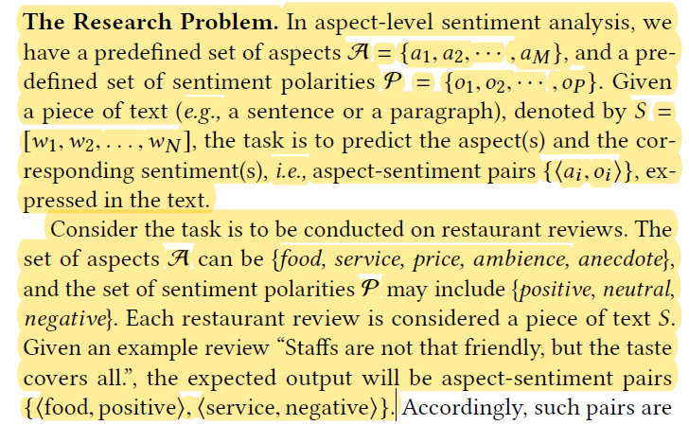

To summarize, the main contributions of this work are as follows:

We propose AS-Capsules model to simultaneously perform aspect detection and aspect-level sentiment classification.

The proposed AS-Capsules model does not require any linguistic knowledge to achieve state-of-the-art performance.

2 RELATEDWORK

Aspect Detection. Aspect detection aims at identifying aspects about which users express their sentiments.

Aspect-level Sentiment Analysis. Aspect-level sentiment classification deals with fine-grained classification with respect to specific aspect(s).

3 ASPECT-LEVEL SENTIMENT CAPSULES

3.1 Preliminary: RNN-Capsule

Recurrent Neural Network A recurrent neural network (RNN) is able to exhibit dynamic temporal behavior for a time sequence through connections between units. A unit can be realized by an LSTM model, a GRU model, or their variants.

RNN-Capsule. RNN-Capsule is designed to predict the sentiment category (e.g., positive, negative, and neutral) of a given piece of text.

There are two learning objectives in RNN-Capsule network. The first is to maximize the state probability of the capsule corresponding to the ground truth sentiment, and to minimize the state probabilities of other capsule(s). The second is to minimize the distance between the input representation and the reconstruction representation of the capsule corresponding to the ground truth, and to maximize such distances for other capsule(s).

3.2 The AS-Capsules Model

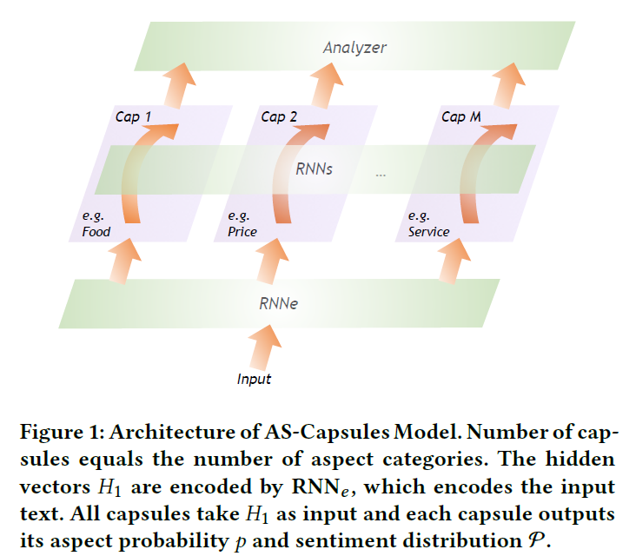

3.3 Structure of A Single Capsule

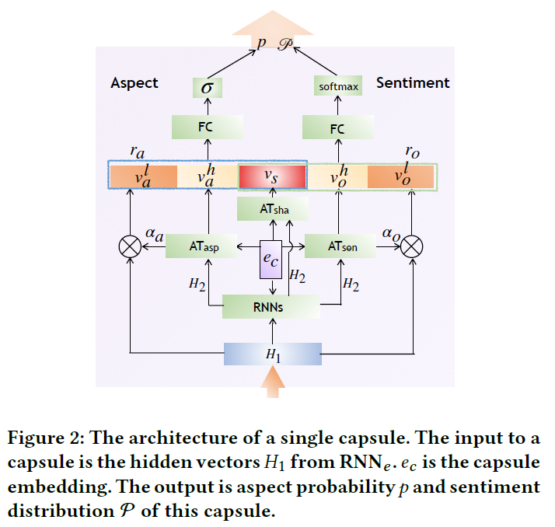

Aspect Representation Module

Aspect Probability Module

Sentiment Representation Module

Sentiment Distribution Module

3.4 Training Objective

The training of the proposed AS-Capsules model has two objectives. One is to maximize the aspect probability of active capsule(s) matching the ground truth and minimize aspect probability of the inactive capsule(s). The other is to minimize the cross-entropy of sentiment distribution of active capsules.

Aspect Probability Objective

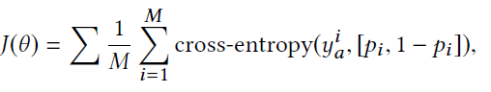

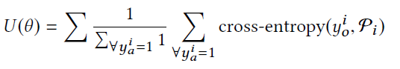 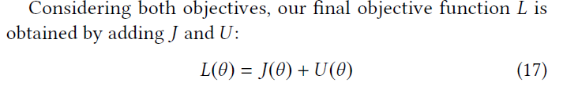

4 EXPERIMENT

4.1 Dataset and Model Implementation Details

Implementation Details

4.2 Evaluation on Three Subtasks

6 CONCLUSION

In this paper, we study aspect-level sentiment analysis and propose aspect-level sentiment capsules (AS-Capsules) model. The key idea of AS-Capsules model is to use capsule structure to focus on each aspect category. Each capsule outputs its aspect probability and sentiment distribution on the targeted aspect. The objective of learning is to maximize the aspect probability of the capsule(s) matching the ground truth and to minimize its (their) sentiment cross entropy loss. Through shared components including capsule embedding, shared encoders and shared attentions, our model utilizes the correlation between aspects and corresponding sentiments effectively.